Saturday

1st Stop: 42nd Street and 7th Avenue

- Times Square The world’s busiest and brightest intersection has enough shops, restaurants, and theaters to keep you entertained for your entire stay. There’s ESPN Zone, a Toys R Us big enough for an indoor Ferris wheel, the largest music store in New York, MTV Studios, Good Morning America, many street performers and vendors, and much more.

2nd Stop: Bloomingdales

- Bloomingdale's has been a Saturday afternoon "see-and-be-seen" institution for decades. This East Side mecca's main floor handbag department has one of the best selections in the city. Visitors can find young designer favorites on the second floor, and the tempting fourth floor shoe salon stocks many of the models seen in fashion magazines.

2nd Stop: Fifth Ave/Central Park

- For many visitors, Fifth Avenue is New York City's must-see shopping destination. Filled with a mix of upscale boutiques, well-known chains, and attractions like Rockefeller Center and St. Patrick's Cathedral, this area is home to stores such as Tiffany & Co., Fortunoff, Piaget, and Wempe Jewelers; the most famous toy store in the world, the flagship FAO Schwarz; the Disney Store for classic Mickey memorabilia and more; the NBA Store and NikeTown showcases for cool athletic apparel.

3rd Stop: 34th and 5th Ave (Herald Square and Empire State Building)

- Macy's Herald Square, the world's largest department store, is one of New York City's most famous retail icons and is renowned for its annual Thanksgiving Day Parade. With 10 floors and half a million items for sale, it's a good idea for first-time shoppers to head up to the Visitor's Center on the 34th Street balcony.

- Empire State Building, The beautiful lights that grace the top of The Empire State building are energy efficient as well as awe inspiring. In fact, as a Tourism attraction, the view from afar can be as exciting as the view from the top! At 1,050 feet (320 meters), reached by high speed, automatic elevators, has both a glass-enclosed area, which is heated in winter and cooled in summer, and spacious outdoor promenades on all four sides of the Building. High-powered binoculars are available on the promenades for the convenience of visitors at a minimal cost.

4th Stop: Financial District / World Trade Center Viewing
- There is a WTC viewing area, open 9am – 9pm, at Liberty Street and Broadway. Tickets are no longer required. Groups do not need to make special arrangements to visit the site.
- Century 21 is a department store that features amazing discounts (25% to 75% off retail) on top designer clothing and other merchandise.
- The winding, narrow streets of Lower Manhattan are an exciting juxtaposition of colonial-era edifices and towering temples of Wall Street capitalism. Numerous landmarks and museums remain as permanent reminders of the area's rich history. How's this for provenance: The museum was the law office of Alexander Hamilton, first Secretary of the Treasury, and is in the former headquarters of John D. Rockefeller's Standard Oil Company. Not far from the museum are the New York Stock Exchange and the Mercantile Exchange, which trades in gold, precious metals, and other commodities. Other fascinating monetary landmarks include the Federal Reserve Bank, which houses more gold than Fort Knox, and Trinity Church, where Alexander Hamilton is buried.

5th Stop: South Street Seaport

- This Financial District waterfront development has more than 100 shops, cafes, and restaurants. Who knew you could eat outdoors with a view of the harbor, tall ships and speedboats cruising by in NYC? Great views of the Brooklyn Bridge, too.

Sunday

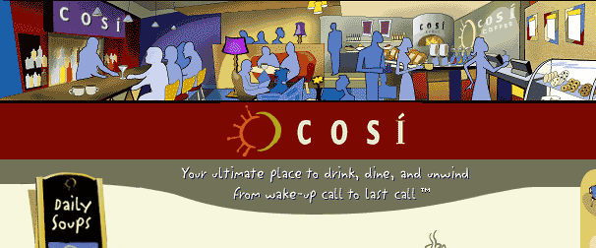
1st Stop: Brunch @ Cosi’s

2nd Stop: Shopping at East Village / Union Square (14th and Broadway)

- A walk down one of the hippest - and cheapest - shopping areas in the East Village will get you anything from T-shirts to jewelry to incense. The young, eclectic crowd (New York University is nearby) makes for great people watching even if you’re not shopping. Eighth Street between 5th and 6th Avenues has probably more trendy shoe stores in one block than anywhere else in the world.

- Shopping area includes: Zara, Virgin MegaStore, H&M, Banana Republic, Gap, Jcrew, Movado, Eddie Bauer, Zales, Yellow Rat Bastard, French Connection, Wet Seal and many many many shoe stores…..

