Week 6. Eco-indicators 99

The LCA flow diagram of Eco-indicators 99 (This diagram and much of the following material is derived from “Manual for Eco-indicators 99” by Mark Goedkoop, Suzanne Effting and Marcel Collignon, ,PRé Consultants B.V.,Plotterweg 12, 3821 BB, Amersfoort, (info@pre.nl)).

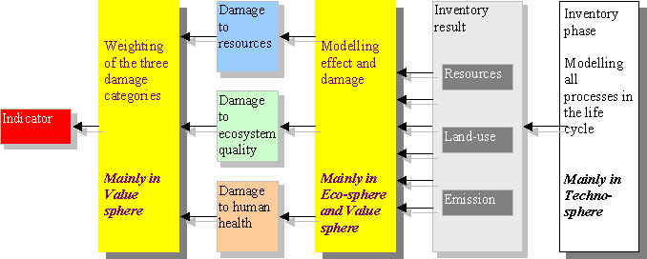

Environmental effects of products
Every industrial activity and product damages the environment to a certain extent. Raw materials must be extracted from the ground and trees cut; then trucks, trains, ships and planes must transport these materials to manufacturing locations and their products has to be packaged and distributed. During use, some of these products may require additional resources , such as electricity or gasoline. Finally, the used products must be recycled or disposed.
As discussed earlier, in the Life Cycle Assessment of the sum total of the environmental impacts of a product, all the stages of its life must be examined and quantified. In conducting an LCA, it is relatively easy to determine the contribution of a particular stage of operation to a certain environmental problem, such as the greenhouse effect, acidification, eutrophication, etc. A difficulty arises when one wants to add up the various impacts and produce a single number that can be compared to an alternative process or product. To do so meaningfully, one needs to use the proper weighting factors, as discussed earlier.
The second problem with carrying out LCA studies is that if one has to start from “scratch” every time, it is a very complex and time-consuming process. Eco-indicators 99 has attempted to overcome these problems by a) providing a weighing method that allows summing up of individual impacts, and b) developing a library of Eco-indicator values for the most common material and processes used in industrial activities. It is expected that this data base will become richer in the future as more people use this method and their experience is used to refine this system of measuring environmental costs.
The students in this course are also challenged to look at the Eco-99 values critically, question those that do not seem to make sense, use the system in their IE term papers and, later, in their careers as Earth and environmental engineers. Eco-indicators 99 are defined in such a way that they fit together like building blocks. E.g., there is an indicator for the production of a kilo of polyethylene, one for the injection molding of a kilo of polyethylene and another for the incineration of one kilo of used polyethylene. In the Eco-99 system, the higher the number of the indicator, the greater is the environmental impact. After all, it represents the environmental cost of a certain human activity.

Uses and limitations of Eco-indicators 99
During the design of a product or process, a large number of options are examined and the best options identified. In the economic system, these options are “weighed” in terms of number of dollars per unit of production, unit of service, etc. Therefore, when all other factors are equal, the lowest cost option is preferred. Similarly, in the environmental system, the available options are “weighed” in terms of their respective Eco-indicator values. The lowest Eco-99 value signifies the best option from an environmental perspective. It can be seen that the Eco-indicator system of measurement provides a value system for measuring environmental performance, much as the traditional cost-benefit analysis has done over the centuries for the economic systems.
“Rome was not built in one day” and it will take a long time for people to pay as much attention to the new system as they have learnt to do with the economic system that offers immediate awards and punishment (try to skip paying your rent to Columbia over two months). The developers of Eco-indicators 99 stress that it is a tool intended for internal use by producers and manufacturers and should not be used to prove to the public that one’s product is better than the competition. Yet, when the public starts worrying and environmental value systems start to intersect and mother about the environment and choosing its purchases accordingly, the economic Earth can take a deep breath of relief.

Units and dimensions of Eco-indicators
From the perspective of physics, the standard Eco-indicator values are dimensionless, same as the units of currency. In the Eco-99 system, the unit of measurement is called the Eco-indicator Point, Pt, and is divided into 1000 millipoints (mPt). The main purpose of having a unit of measurement is so as to be able to compare alternative options for materials, products and processes (by the way, the same need led to the beginning of the currency era). Apparently, the size of the Pt unit was chosen by Eco-99 to represent one thousandth of the yearly environmental load of an average citizen in Europe. The kilopoint (1 kPt=1000 points) was derived by dividing the computed total environmental load in Europe by the number of its inhabitants. So, if you have a friend in France she imposes a load of one kilopoint (kPt) on the planet each year, and so do you, give or take a few hundred Pts.

Description of the standard Eco-indicators 99
Standard Eco-indicator 99 values are available for:
- Materials: The indicators are expressed per kilogram of material
- Production processes (treatment and processing of various materials): Expressed per physical unit that is appropriate to the particular process (e.g., square meters of rolled sheet or kilo of extruded plastic).
- Transport processes: Expressed mostly per ton-km (q metric ton-1000 kg)
- Energy generation processes. Units are given for electricity and heat.
- Recycling or disposal processes. These are expressed per kilo of material and are subdivided into types of material and waste processing methods.
Average European figures are used for this calculation. A particular definition was used for the terms “material” and “process” when determining the indicators. The definitions used are explained briefly below.

a) Materials
Materials range from the primary resources of the Earth (ores and their concentrates, coal/oil/gas, forest and agricultural products), to refined (cement and other industrial minerals, metals, refined coal/oil/gas, lumber, pulp, processed food), and manufactured (chemicals, metal tube/sheet/wire, petrochemicals, paper, wood) products. In determining the indicator for the production of materials all the processes are included from the extraction of the raw materials up to and including the last production stage, resulting in bulk material. Transport processes along this route are also included up to the final process in the production chain. Which process that is, can be derived from the explanation in the Eco-indicator list. For plastic, for example, all the processes are included from extraction of the oil up to and including the production of the granules; for sheet steel all the processes are included from extraction of the ore and coke up to and including the rolling process. The production of capital goods (machines, buildings and such like) is not included.

b) Production processes
The Eco-indicators for treatment processes relate to the emissions from the process itself and emissions from the energy generation processes that are necessary. Emissions during the manufacture of capital goods, like machines and dies, are not included on the grounds that over the life of a plant (20years+) they are distributed over a large number of production units and, therefore. Are negligible. However, this may not be the case in comparing process options, e.g. combustion or landfilling of solid wastes where plant equipment and land-use are very important.

c)Transport processes
Transport processes include the impact of emissions caused by the extraction and production of fuel used in trains, ships and planes and by the conversion of fuel to mechanical energy during transport. Environmental impacts are expressed per one metric ton(1000 kg) of goods transported over a distance of 1 km (1 ton-km).
Transport by road: For transport of materials by road, where the capacity of a truck may be limited not by weight but by the volume of low-density materials, the environmental impact may also be expressed per cubic meter (m³) transported per kilometer (m³-km). Capital goods, like the production of trucks and road or rail infrastructure, and the handling of cargo planes on airports, are included as they are not negligible.
Rail transport: The impacts for rail transport are based on the average European ratio of diesel to electric traction and average load level of a car..
Air transport (cargo planes): A loading efficiency for European average conditions is assumed and account is taken of a possible empty-return journey.
Energy: The energy indicators refer to the extraction and production of fuels and to energy conversion and electricity generation. The European industry average efficiency is used and account is taken of the mix of various fuels used in Europe to generate electricity. Also, Eco-indicators have been determined for high-voltage electricity that is used in industrial processes and for low-voltage electricity, used in residential, commercial, and light industry applications. This accounts for line transmission losses.
In addition to Europe-average indicators, Ei-99 also provides specific indicators for a number of countries. The large differences between countries are explained by the vintage and efficiency of different technologies used to produce electricity. One of the IE term papers in this class will deal with determining equivalent indices for the U.S. industry.

d) Recycling or disposal of used materials
In the recent past, the only concern about used materials and products was where to dispose them so they could not be seen or smelled. There was little consideration as to their properties, value or effects on the environment. Even today, well meaning people who truly want to protect the environment can be passionate about what should be done with what they consider to be a generic material, called wastes. Industrial ecologists, such as the Ei-99 developers and faculty in this school, are trying to shed some scientific light on this difficult subject. Wastes, and in particular what is called municipal solid wastes (MSW), consist of all phases and practically all materials that exist on this planet. Taking such materials and burying them in a common “grave”, as is presently done for most MSW, is an insult to the Earth and also to human intelligence. Yet, in the U.S. it is encouraged by federal legislation.
Of course, the first thing to consider in process/product design is how to minimize the materials/energy to be used in production and marketing/distribution of a product (packaging, etc.). However, you cannot make an omelet without having egg shells to dispose of. For as long as people want to be fed, clothed, housed, and entertained, there will be used materials to dispose of.
Municipal Solid Wastes
With regard to MSW, the higher density materials (metals, glass, and ceramics) do not decompose nor burn and are the easiest to separate physically and recycle. However, if their sorting is done manually, a large fraction still ends up in landfills. Glass and ceramics are inert materials but metals in landfills continue to oxidize for centuries after a landfill closes.
Manual sorting of papers and plastics can result in some recycling of these materials while the rest goes to landfills. Paper and plastics are recycled to some extent but, in most U.S. communities, nearly two thirds end up in landfills. They range from "difficult to impossible" to decompose so they lie in a landfill for decades or centuries. Their gradual decomposition results in a reduction of volume so that the cover and walls of a closed landfill may subside with time resulting in rupture of mechanical barriers (liners, etc.) and seepage of corrosive solutions into the groundwater or adjacent surface waters. Also, any organic material such as papers (cellulose) and food/plant wastes that is buried in a landfill continues to decompose anaerobically (i.e., in the absence of oxygen) with time and produce methane gas which is a greenhouse gas (GHG) that is about 20 times more potent than carbon dioxide. During the active life of a landfill, some of this gas may be collected and used; after the landfill closure, any methane gas generated is emitted to the atmosphere.
However, this paper/plastics composite material has a "heating value" that is nearly the same as some U.S. coals. Therefore, it can be used as an alternative fuel to fossil fuels for generating electricity. In fact, it is used as such in Waste-to-Energy plants in enlightened communities in the U.S. and many other developed countries. Nearly 16% of the U.S. MSW is processed to recover energy.
The remaining class of materials are food and plant wastes. This is what is called the "wet" stream of MSW. This material cannot be recycled and if combusted has a very low heating value. However, the “wet” stream decomposes easily aerobically (i.e., in the presence of oxygen) to produce a compost product that can be used as a soil conditioner) or anaerobically, in a bioreactor, to produce methane gas and a compost product.

Using the Eco-indicators 99 in evaluating waste disposal routes
When using the Eco-99 indicators to evaluate waste processing and disposal options, careful consideration must be given to their properties and to the waste processing method that is the most appropriate. Wiith regard to products that consist mainly of paper or glass, it is reasonable to assume that a large fraction of households will remove these materials from the waste stream and dispose of them into separate recyclable streams. For example, the NYC Bureau of Recycling (Department of Sanitation) has been able to recycle over 20% of the total MSW stream, in the form of paper, glass, and plastics.
However, products that consist of mixed materials cannot be sorted to separate streams manually. As noted above, such materials need to be subjected to physical processing/sorting by mechanical methods and then recycled, or combusted to produce energy, or in the last resort landfilled. The Ei-99 method has calculated scenarios for the recycling, combustion, or landfill disposal of products:
• Household waste. In an average household, a number of materials such as glass, paper and compostable waste are collected and recycled separately once the decision has been taken to dispose of a product. The rest is put in the dustbin and is thus routed to the municipal waste collection system. The household waste scenario is based on the waste handling in an average household in Europe.
• Municipal waste. The municipal waste scenario, is modeled after the average processing of waste in Europe. It is assumed in this that a certain proportion is landfilled and the rest is combusted. The environmental impact of transport of wastes is also included.
• Combustion. This scenario assumes that combustion is carried out in an average Swiss Waste-to-Energy plant equipped with an average (year 2000) gas cleaning system.. A proportion of the steel and aluminum is also reclaimed and recycled from the incinerator slag. In addition, energy is generated and supplied to the grid as electricity. The Swiss performance of WTE plants does not represent the average for Europe but it is expected that this will change gradually in the coming years. Combustion of wastes generates electricity and thus decreases the amount of coal or oil that need to be mined for that purpose.
• Landfill disposal. Landfill disposal is also based on modern Swiss landfills (year 2000) equipped with good water barriers and leachate purification systems, so that relatively few harmful substances can escape to groundwater sources.
• Recycling. Recycling processes have a certain environmental impact, like all other industrial activities, but they also result in the production of useful products. These products decrease the amount of minerals or forest products that need to be used and therefore represent an environmental gain. The Ei-99 tabulation presents both the environmental load as the environmental gain. However, these two items can differ considerably from case to case, depending on the purity of the input materials, quality of the output materials, and other factors specific to each case. Therefore, Ei-99 suggests that their waste indicators represent a rather ideal and thus optimistic situation. In some of the term papers in this course we will attempt to refine these numbers for U.S. conditions.
Ei-95 waste data have been determined for most important plastics, metals and packaging materials. They do not include processes for treating construction materials and chemicals. Construction (other than wood and plastics that can be combusted) can be reused for road or foundation building, in place of stone aggregate in concrete, or as landfill cover. Chemically inert materials, such as construction debris (excepting wood) and bottom ash from WTE plants, have no other environmental impact than that they occupy an area in a landfill. Ei-99 provides a general figure per landfill volume used. This value is valid under the assumption that the ultimate height of the landfill is 10 meters. For shallower landfills, this figure is proportionally higher (e.g. double the 10-m figure for a 5-m landfill). The disposal of chemicals present a more complex situation and Ei-99 does not provide any values except for the disposal of refrigerants.

Negative figures for waste processing
When the waste processing results in a useful by-product that can be recycled or reused, the reclaimed materials and energy values represent an environmental profit. Therefore the net value of a disposal process can be a negative number. For example the environmental impact of processing of 1 kg of scrap iron is equal to the impact of the scrap smelting process minus the impact of the process that produces the same amount of iron from iron ore.

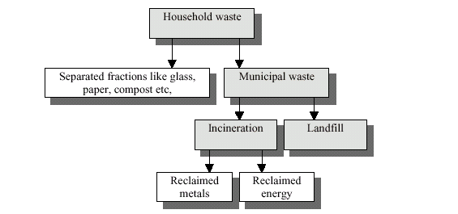
Eco-indicator 99 flowsheet of options for disposing Municipal Solid Wastes (MSW). Option of separation of “wet” and “dry” streams at source and of composting the “wet” stream are not shown. A better term for “Incineration” is “Waste-to-Energy (WTE) or “ Combustion and Energy Generation” (CEG).

Inventory of the processes
The standard Eco-indicators 99 have been based on the energy database developed by ESU-ETH in Zürich [ESU 1996]. Also, data from the SimaPro LCA software tool (see www.pre.nl web address) have been used. In the inventory of such data it is very important to use a consistent methodology concerning items like:
- System boundaries (what is to be included in analysis).
- Allocation (how to deal with industrial processes that produce more than one output).
- Regional aspects (Ie-99 uses Dutch, Swiss or average European data).
- General data quality issues. A brief description of such these issues follows.
Also, Eco-99 recommends that that users of their methodology do not mix their database with indicators that have been developed by other methodologies.

Uncertainties
Two types of uncertainties are noted in the methodology that is used to calculate the indicators:
- Uncertainties about the correctness of the models used.
- Data uncertainties.
The first type includes value choices like the choice of the time period of to be used in the damage model, or whether to include a particular effect when there is not as yet sufficient scientific proof of its environmental impact . The data uncertainties refer to difficulties in measuring or predicting effects. This type of uncertainties is relatively easy to deal with and can be expressed as a range, or a standard deviation from the reported value.

Uncertainties about the correctness of the model
These uncertainties are very difficult to express quantitatively. In debates about the seriousness of environmental effects opinions are usually very diverse, even when the evidence is overwhelming (e.g. the global warming effect). This is due to differences in economic interest, knowledge level, or fundamental differences in attitude (e.g. anthropocentric vs biocentric views of the Earth). Some people would argue that long-term effects are very important, while others believe that in the long-term new ways will be found to solve the environmental problems of future generations.
Such differing perspectives are also present in the economic system. For example, many people believe that the money they earn is due only to their hard work and not at all to the society in which they have thrived; therefore, there can be no societal claim to a fraction of their income in the form of taxes. The developers of Eco-indicator 99 were also confronted with model choices that are dependent on such different perspectives. To simplify matters, they used three “archetypal” perspectives that are representative of the principal perspectives in public with respect to the environmental system:

The three “archetypes” in Eco-indicators 99

Type | Time perspective | Ability to manage | Required level of evidence
Hierarchist (I) | Balance between  short and long term | Proper policy can avoid  many problems | Inclusion is based on  consensus
Individualist (I) | short term | Technology can avoid many problems | Include only proven effects
Egalitarian (E) | long term | Problems can lead to  catastrophy | Include all possible effects

The Ei-99 “Archetypes” were taken from the Cultural Theory framework (Thompson 1990 and
Hofstetter 1998), and are frequently used in social science. This theory does not imply that there are just three types of people; the three archetypes are conceptual models that most people use to some degree in their daily life (e.g. an egalitarian in public life may very well be a hierarchist at home). The Eco-indicator 99 methodology presented here is based on the Hierarchist (H) type that is considered by Eco-99 to be the default perspective . However, the full Eco-99 LCA software provides data for the other two types so that LCA modelers can assess the influence of the other two types on the result of the LCA.

Data uncertainties
Examples of data uncertainties are: uncertainty in the expected number of cancer cases when a group of people are exposed to a certain substance; uncertainty of the concentration of a certain contaminant in the sediments of a harbor; uncertainty of the impact of this contaminant on the various ecosystems in the harbor. The Eco-99 “Methodology Report” describes the data uncertainties for nearly all reported human health effects and for most ecosystem effects.. However, the degree of uncertainty in the acidification, eutrophication and resources data is not available as yet.
In considering uncertainties, it is important to distinguish between the absolute and relative
uncertainties. The latter denotes uncertainties in the differences between indicators. The relative uncertainty is very important when the LCA is applied in comparisons of material or design options; thankfully, the relative uncertainty is usually smaller than the absolute uncertainty. This is because these uncertainties are correlated (e.g. in comparing material A to material B) and tend to compensate each other. For example, let us assume that product design A uses 1 kg of polyethylene and design B 1.2 kg; if the source of polyethylene is the same for the two cases, although there may be some uncertainty in the absolute value of the environmental impact of polyethylene, it is safe to assume that its use in design B will have an impact that is 20% higher than in design A.
On the other hand, if product design B uses wood rather than polyethylene, the uncertainties can be very significant, as the processes and the most important emissions and resources are very different. A flaw in the damage model for extraction of oils to produce polyethylene is not compensated by a similar flaw in the production process of wood. Similarly, a flaw in the model for land-use (production forest) is not compensated by the flaw in the model for a refinery, as the amount of land used per kg of oil is low. Accordingly, Eco-99 recommends that when entirely different materials or processes are used, one must allow for a large error margin before choosing a particular option.
As a very provisional and general measure, Ei-99 recommends the following guidelines in LCA comparisons:
a) Determine the most important processes (processes with the highest impact contributions)
b) Determine if these processes are expected to have similar or dissimilar raw materials, operating conditions, and emissions.
c) If the dominant processes are considered to be quite similar, the difference between the Eco-indicator scores should be greater than 10 to 50% (up to the discretion of the LCA analyst) in order to warrant selection of the lower impact option.
d) If the dominant processes are considered to be dissimilar or entirely different, the Eco-indicator scores should differ by more than 100% before a reliable conclusion can be drawn.

Steps to follow in using the Eco-indicators system for LCA
- Establish the purpose of the Eco-indicator calculation.
- Define where the life cycle begins and ends.
- Express materials, energy and processes quantitatively
- Fill in the Eco-indicator form
- Draw conclusions from the information on the form.
Ecco-99 recommends that a “rough” calculation is carried out first. This ensures that you do not waste too much time with details.

Step 1: Establish the purpose of the Eco-indicator calculation
• Describe the product or product component that will be analyzed.
• Decide whether this is an analysis of a specific product is or a comparison
amongst several products.
• Define the level of required accuracy of the analysis.
As an example of how a comparison can be simplified, if the same process is involved in product A and product B, it need not be included in the analysis.

Step 2: Define the life cycle
• Draw up a schematic overview of the product’s life cycle, including feed materials, production, use, and waste processing. As an example, the simplified life cycle of a coffee machine for domestic use is shown below in the form of a process flow sheet.

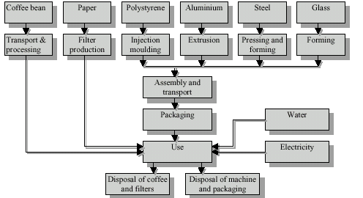

Simplified process diagram of the life cycle of a coffee machine (Eco-99)

Step 3: Quantify materials and processes
• Determine the most important functional unit .
• Quantify all relevant processes from the process tree.
• Make assumptions for any missing data.

Since all details of a product life cycle may not be known, it may be necessary to make reasonable estimates of the missing elements or assume them to be negligible; generally, it is better to err on an estimate, and improve on it later when better information becomes available than to ignore something that may later be found to have overriding importance.

Examples of functional unit
The purpose of the coffee machine is to make coffee and keep it hot. The following are therefore chosen for the functional unit: all the products and processes needed for the provision of coffee for a household for a certain period. A certain period then has to be specified (e.g., five years) and the average coffee consumption per household estimated (e.g., capacity of 5 cups of coffee twice a day and keeping it hot for half an hour after brewing). The number of filters (3650) and the energy consumption can then be calculated on the basis of this assumption. Two options may be considered, a hot plate under the coffee pot or a thermally insulated pot.
As another example, in comparing landfilling to composting of solid wastes, the functional unit would be one ton of material to be treated. In comparing sources of energy, the functional unit would be 1 Joule or 1 kWh.

Step 4: Filling the Eco-99 form
• The processes and amounts of materials involved are noted on the form.
• The appropriate Eco-indicator values are obtained from the E-I lists and are entered on the form.
• The number of Points are calculated by multiplying the amounts by the indicator values and the products are summed up to yield the resultant Eco-99 value.
Ei-99 has developed a simple form to be used in this type of LCA analysis. When an indicator for a particular material or process is not available, the following steps are suggested by Ei-99:
• Consider whether the missing indicator would make a significant contribution to the total
environmental impact of the product/process under analysis. It is generally better to try to estimate than to omit a certain component of the life cycle.
• Substitute a known indicator for the unknown one. For example, if you examine the Ie-99 tables of indicators, you will see that indicator values for plastics are close to each other. On this basis, you may be able to estimate the Eco-indicator value for a “missing” plastic that is within this range.
• Ask an LCA specialist to calculate a new indicator value or consult one of the software packages that have been developed for this purpose.

Step 5: Interpretation of results of analysis (suggested by Eco-99)
• Formulate preliminary conclusions on basis of results of analysis.
• Examine the effect of changes in assumptions and in uncertainty elements on results (sensitivity analysis).
• Amend conclusions on basis of sensitivity analysis.
• Review initial goals of life cycle analysis and determine whether they have been met or what more need to be done.
In drafting your conclusions on the basis of the results obtained, discuss which processes and phases in the life cycle were found to be the most important and which alternative had the lowest score. Also, discuss frankly the assumptions you have made and the effect that uncertainties in the data may have had on the results obtained and the conclusions reached. If you feel that a definite conclusion cannot be reached with the information at hand, state so clearly, it is useful to know what we do not know.
A general word of advice: The more radical a result of an analysis may seem to be, with relation to prevalent thinking in the scientific/technical community, the more you need to ensure that you have taken all factors into consideration and that the “facts” you have used are checked and rechecked.

Examples of application
Example 1. Simple analysis of a coffee machine
A design team is designing a new coffee machine for domestic use, taking into full consideration the associated environmental aspects. They start by an analysis of the current model.
Step 1: Establish the purpose of the Eco-indicator calculation
The purpose of the calculation is to establish priorities, i.e., “where can the designer best start to achieve the greatest possible environmental improvement?” Therefore, the purpose is not to compare two coffee machines. Rough calculations and simplifications are permissible at this stage.
Step 2: Define the life cycle
The “process diagram” of a coffee machine was shown earlier. It is a simplified model of a coffee machine (e.g. it does not include the cable that connects it to a wall plug) which shows only the polystyrene housing, the glass coffee pot, the steel hot plate and an aluminum riser tube. The white blocks in the figure below are not included in the analysis. The consumption of coffee and water have been omitted because they are common to all coffee machines. Also, the packaging materials are not under study at this stage.

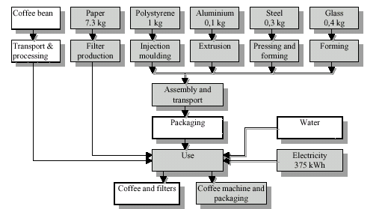
Simplified process diagram of the life cycle of a coffee machine showing amounts of materials and energy used in the dominant (shaded) process steps (I-e 99)

Step 3: Quantify materials and processes
The amounts of materials and energy used in the life cycle of the coffee machine can be derived from the design specifications or, for an existing machine, by disassembling and weighing the components. An assumption of the frequency of use is needed for the required amount of electricity and the number of filters. In this example, it is assumed that the machine is used twice a day for five years at half capacity (5 cups). It is further assumed that the coffee is kept hot for half an hour after it is ready. Next, it is easily calculated that 3650 filters will be needed with a total weight of 7.3 kilograms. As a first approximation, the consumption of electricity is determined by multiplying the time taken to brew the coffee by the rated power of the machine (the Cuisinart of your instructor is rated at 1000 kW). For a non-insulated coffee pot, the energy consumption for keeping the coffee hot can be estimated by measuring the current-time relationship of an existing machine.
Consumer behavior at the disposal stage will depend on the recycling system at a particular geographic area. In this case it is not reasonable to assume that the machine will be dismantled and disposed of separately in different metal/plastic collection systems by the consumer. It is therefore assumed that the machine will be put in the NYC “black” bag and processed as municipal waste. The glass pot may be disposed in the NYC recycling “blue” bag. For this reason it is not necessary to include a separate glass recycling stage in the calculation (see the sample form). In NYC, the 7.3 kg of paper filters will end up in the black bag and go to a landfill. In communities that collect the “wet” stream separately, the coffee filters will end up in the composting plant., along with other organic waste.

Step 4: Fill in the form
The form can now be filled in for each phase in the life cycle and the relevant Eco-indicator values can be recorded. Be careful with the units of measurement of each quantity, apples should not be added to oranges. The score is then calculated for each process and recorded in the “result” column.

As mentioned earlier, the Eco-indicator 99 list may not include as yet all of the required processes and assumptions need to be made for the missing data. In this example, this involves a number of treatment processes and waste processes. The following assumptions are necessary:
• The indicator values for stamping and forming of steel are low. Therefore, the processing of the metal in the coffee machine can be disregarded.
• There are no data for the glass forming of the coffee pot. However, an estimate of the amount of energy can be made (in this case 4 MJ) based on the melting point, the specific heat and an assumed thermal efficiency of a glass furnace (of course, for more accurate value of energy usage you can search the glassmaking industry literature).
• There is no indicator value for the composting component of the disposal process. Two approximations are possible:
- Ignore the possibility of composting and assume that all the paper ends up in the municipal waste processing system.
- Assume that composting has a negligible impact and can thus be omitted. In this example it was assumed that all the paper ends up in the municipal waste processing system.

Example of Ei-99 form with data for various processes in life cycle of coffee machine
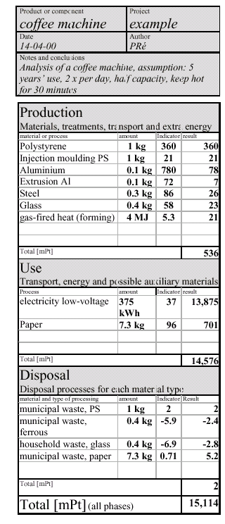
Step 5: Interpretation of the results
The results on the form show that the use phase has the greatest impact. The number of points is many times higher than the totals for the production and waste phases. Therefore the design team for a new machine should assign highest priority to lower energy consumption.
Reducing paper consumption by using a re-usable metal screen is a clear second priority. With regard to materials use, the highest priority is redesign of the polystyrene housing.
Verification
The effect of assumptions made in this case is negligible, apart from the assumption regarding use (and the service life). The measured electricity consumption is reasonably reliable, but the assumption that coffee will be made twice a day for five years and kept hot for half an hour is not based on any concrete data. However, the results show that even if the machine is used only once a week, the conclusion that energy consumption is predominant will not be affected.
The indicator values relating to the assumption for the disposal of aluminum and paper do not give rise to any other conclusions. Even with accurate waste figures, the contribution of the waste phase will remain only a fraction of the indicator for the use phase.
Improvements
On the basis of the above evaluation, the design team may consider developing a coffee machine with a thermos jug instead of a hot plate. In addition, the coffee machine could be fitted with a permanent filter in place of one-time use paper filters. These design alternatives can, of course, be calculated in the same way with the Eco-indicators 99.

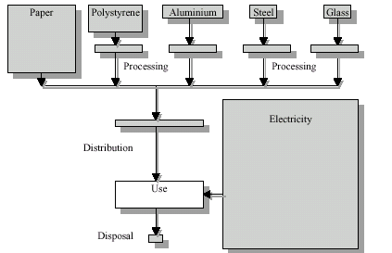

Simplified process diagram of the life cycle of a coffee machine with size of each block representing the respective environmental impact (Ecco-99)

Home exercise: The instructor’s Cuisinart coffee maker was found to brew five cups of coffee in 8 minutes from a “cold start” It then shuts off automatically. It is equipped with a thermos jug that doubles the amount of plastic material used to make the coffee maker discussed above. Also, it uses a metallic screen filter instead of paper filters; it take s one liter of water to wash this screen after use. If both machines are used once a day for a period of five years, calculate their respective Eco-indicator values over that period.

Example 2. Analysis of a complex product
For products that consist of several components, the Ei-99 form can be filled for each component or “sub-assembly”. In the same way as is done for engineering drawings (structural, electrical circuits, etc.). The Ei-95 form is used for each sub-assembly and the total scores of all sub-assemblies are carried over to the main form which can also include the “use” phase of the life cycle of the product. The following figure illustrates the application of this method in the evaluation of a refrigerator.

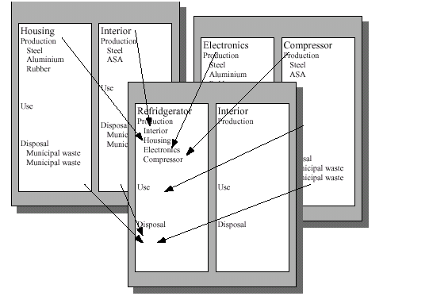
Summing up the results of the analysis of the sub-assemblies of a refrigerator

The tables shown below show the Point evaluation of various materials and processes (Eco-indicators 99)
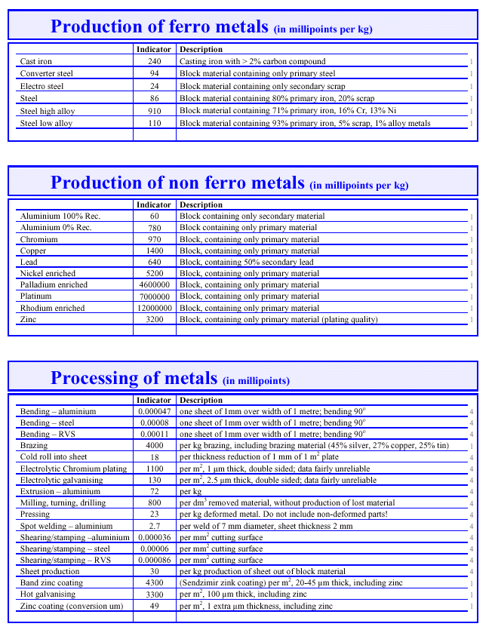

[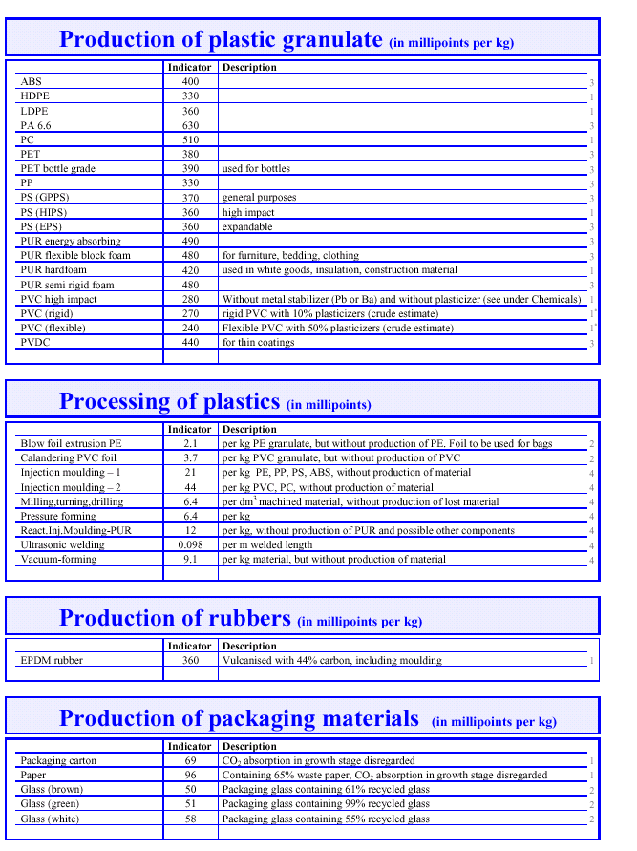

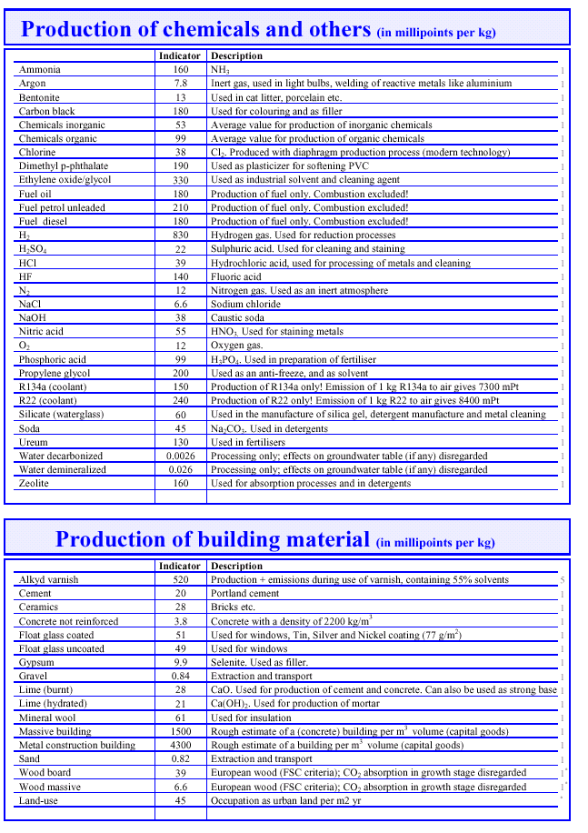

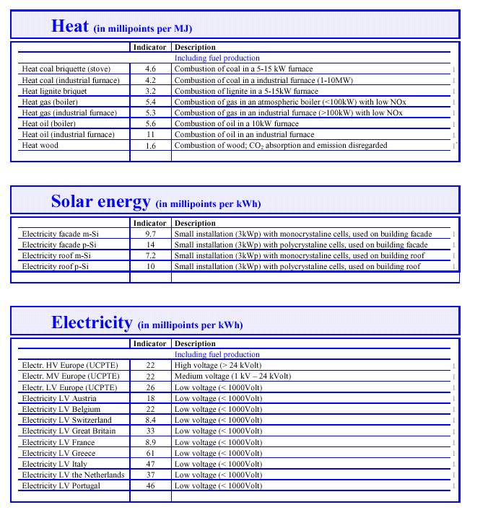

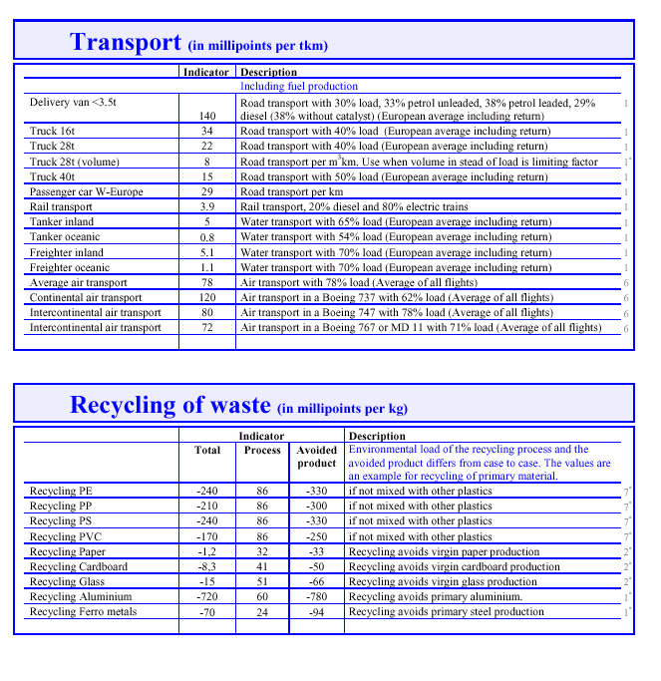

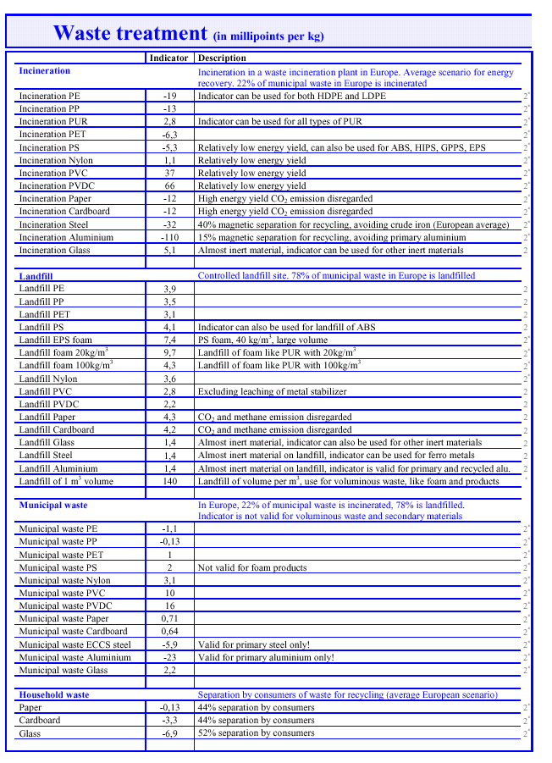

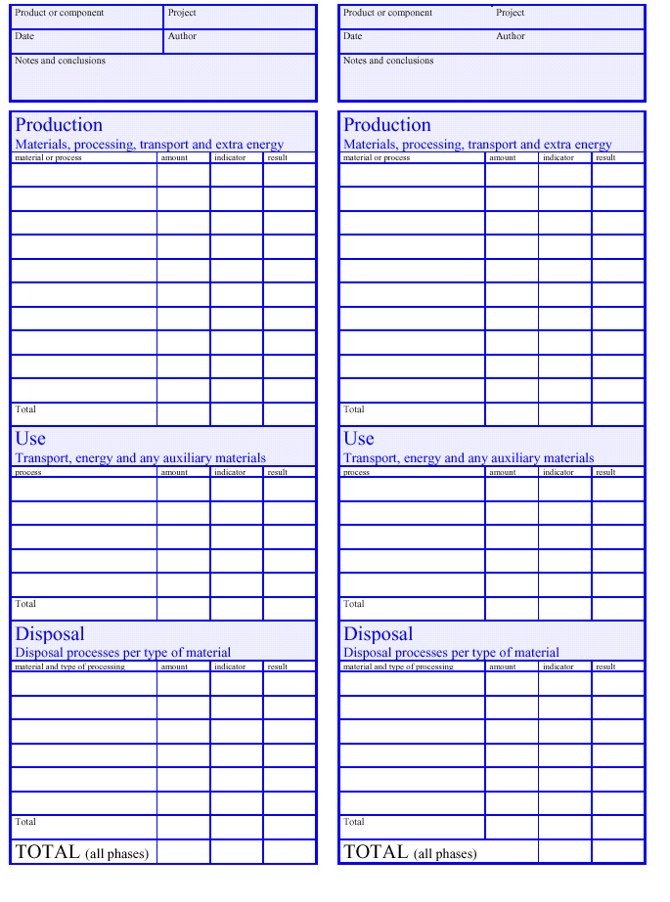

References to Eco-indicators 99 Methodology
Campbell 1998] Campbell, C.J.; A Guide to Determining the World’s Endowement and Depletion of
Oil, March 31, 1998, Petroland Consultants. see also www.hubbertpeak.com/
campbell/ guide.htm
[Chapman 1983] Chapman, P.F.; Roberts, F. (1983): Metal Resources and Energy. Butterworths
Monographs in Materials
[ESU 1996] Frischknecht R. (final editor), U. Bollens, S. Bosshart, M. Ciot, L. Ciseri, G. Doka,
R. Hischier, A. Martin (ETH Zürich), R. Dones, U. Gantner (PSI Villigen), 1996.
Ökoinventare von Energiesystemen, Grundlagen für den ökologischen Vergleich von
Energiesystemen und den Einbezug von Energiesystemen in Ökobilanzen für die
Schweiz, 3 rd Edition, Gruppe Energie - Stoffe - Umwelt, ETH Zürich, Sektion
Ganzheitliche Systemanalysen, PSI Villigen
[Goedkoop 1995-1] Goedkoop M.J.; De Eco-indicator 95, eindrapport; NOH rapport 9514, juli 1995,
ISBN 90-72130-77-4.
[Goedkoop 1995-2] Goedkoop M.J.; Demmers, M.; Collignon, M.; De Eco-indicator 95 Handleiding
voor ontwerpers, eindrapport; NOH rapport 9510, juli 1995, ISBN 90-72130-78-2.
[Goedkoop 1999] Goedkoop, M.J.; Spriensma, R.S.; The Eco-indicator 99, Methodology report, A
damage oriented LCIA Method; VROM Report -------, Den Haag, 1999
[Heijungs 1992] Heijungs R. (final editor) et al; Milieugerichte levenscyclusanalyses van producten,
handleiding en achtergronden, NOH rapport 9253 en 9254; Leiden; 1992; In
opdracht van het Nationaal Onderzoekprogramma Hergebruik van afvalstoffen
(NOH), in samenwerking met CML, TNO en B&G.
[Hofstetter 1998] Hofstetter, P. (1998): Perspectives in Life Cycle Impact Assessment; A Structured
Approach to Combine Models of the Technosphere, Ecosphere and Valuesphere. ,
Kluwers Academic Publishers, 1998, Info: www.wkap.nl/book.htm/07923-8377-X.
[Köllner 1999] Köllner, T.; Life-Cycle Impact Assessment for Land Use. Effect Assessment Taking
the Attribute Biodiversity into Account., submitted for the Journal of Cleaner
Production. April 1999
[Mettier 1999] Mettier T. : Der Vergleich von Schutzguetern - Ausgewaehlte Resultate einer Panel-Befragung,
in: Hofstetter P., Mettier T., Tietje O. (eds.), Ansaetze zum Vergleich
von Umweltschaeden, Nachbearbeitung des 9. Diskussionsforums Oekobilanzen
vom 4. Dezember 1998, ETH Zuerich).
[Müller-Wenk 1998] Müller-Wenk, R. (1998-1): Depletion of Abiotic Resources Weighted on the Base of
"Virtual" Impacts of Lower Grade Deposits in Future. IWÖ Diskussionsbeitrag Nr.
57, Universität St. Gallen, March 1998, ISBN 3-906502-57-0
[Thompson 1990] Thompson M,, Ellis R., Wildavsky A.; Cultural Theory, Westview Print Boulder
1990

